Complete Project Documentation: ServiceNow Import Sets, Transform Maps & Analytics
Date: 30 September 2026 | Team ID: 6ab4ae09a238dc999eb4ccf4
Project Name: Import Data using Transform Maps (Spreadsheet)

1. Executive Summary & Problem Context
In enterprise IT operations, migrating human resource and personnel records from external formats into core enterprise platforms is a frequent and mission-critical operation. Organizations regularly exchange spreadsheets containing onboarding rosters, departmental transfers, and contact revisions. Performing manual entry is highly inefficient, error-prone, and unsustainable. Directly uploading files into production databases poses severe risks of data corruption, schema mismatches, and duplicate records.
This project presents an enterprise-grade solution built on the ServiceNow Platform leveraging System Import Sets, Table Transform Maps, and Coalesce duplicate prevention rules. Staging tables serve as an isolated buffer, Transform Maps orchestrate automated schema translation, and Coalesce enforcement on Employee ID guarantees idempotency. The system concludes with real-time Business Intelligence reports and an executive dashboard delivering live workforce visibility.
2. Detailed Step-by-Step Implementation (Phases 1 to 9)
Phase 1: Prepare the Sheets
Constructed Google Spreadsheet with 15 initial employee records and exported it as <code>Sample Spreadsheet.xlsx</code>.
Employee ID | Name | Email | Department | Location
SB-0001 | Ratan Kumar | test1@gmail.com | ServiceNow | Hyderabad
SB-0002 | Sandeep Guja | test2@gmail.com | ServiceNow | Hyderabad
SB-0003 | Meghana Katoju | test3@gmail.com | ServiceNow | Hyderabad
SB-0004 | Ajay Kumar | test4@gmail.com | ServiceNow | Hyderabad
SB-0005 | Bitla Sai Prasad | test5@gmail.com | ServiceNow | Hyderabad
SB-0006 | Sushma Ganji | test6@gmail.com | ServiceNow | Hyderabad
SB-0007 | Yaswanth Nikku | test7@gmail.com | ServiceNow | Hyderabad
SB-0008 | Prashanth Reddy | test8@gmail.com | ServiceNow | Hyderabad
SB-0009 | Praneeth S | test9@gmail.com | ServiceNow | Hyderabad
SB-0010 | Ravi Teja | test10@gmail.com | ServiceNow | Hyderabad
SB-0011 | Abhishek S | test11@gmail.com | Salesforce | Hyderabad
SB-0012 | Rakesh Bhoomani | test12@gmail.com | Salesforce | Hyderabad
SB-0013 | Mounika K | test13@gmail.com | Salesforce | Hyderabad
SB-0014 | Sushanth J | test14@gmail.com | Salesforce | Hyderabad
SB-0015 | Srinu Nandipalli | test15@gmail.com | ServiceNow | Hyderabad

Phase 2: Create New Custom Target Table
Navigated to <i>Tables > Create New</i> in ServiceNow Application Navigator:
- Label: Employee Test
- Name: u_employee_test
- Application Scope: Global
- Fields Created (Type: String): Employee ID (u_employee_id), Employee Name (u_employee_name), Email (u_email), Department (u_department), Location (u_location).
Configured the Form Layout using Form Context Menu > Configure > Form Layout to arrange all fields cleanly on the user interface.
Phase 3: Import Set Table & Load Data
Navigated to <i>System Import Sets > Load Data</i>:
- Import Set Table: Create table
- Label: Employee Import
- Name: u_employee_import (auto-populated)
- Source of Import: File > Choose File: Sample Spreadsheet.xlsx
- Sheet Number & Header Row: Sheet 1, Header row 1
Upon submission, the ImportProcessor completed with state 'Complete' and completion code 'Success' (15 records staged).
Phase 4: Create Transform Map
Clicked 'Create Transform Map' on the Import Set progress screen:
- Name: Sample Spreadsheet Import
- Source Table: Employee Import [u_employee_import]
- Target Table: Employee Test [u_employee_test]
Clicked 'Auto Map Matching Fields' and fine-tuned using 'Mapping Assist' to map:
- Field Mapping: u_name -> u_employee_name | u_employee_id -> u_employee_id | u_email -> u_email | u_department -> u_department | u_location -> u_location.
Phase 5: Transform Data & Validate
Executed the transformation. Transform History logged:
- Initial Transform Metrics: Total: 15 | Inserts: 15 | Updates: 0 | Ignored: 0 | Errors: 0.
Navigated to <i>Employee Test [u_employee_test]</i> table and validated all 15 records were successfully created.
Phase 6: Enable Coalesce to Avoid Duplicate Records
Under the Transform Map related list <i>Field Maps</i>, selected <code>u_employee_id</code> and updated <b>Coalesce = true</b>.
Coalesce Rule: When Coalesce is true, the system checks whether the incoming Employee ID already exists in u_employee_test. If a match is found, existing fields are updated. If no match exists, a new record is inserted. If incoming data is identical, the row is ignored.

Phase 7: Inserting New Data in Excel Format (Coalesce Verification)
Constructed delta spreadsheet <code>spreadsheetproject.xlsx</code> with 4 rows:
- Modified Record 1: SB-0004: Name changed from 'Ajay Kumar' to 'Ajay'
- Modified Record 2: SB-0010: Email changed from 'test10@gmail.com' to 'test18@gmail.com'
- New Employee 1: SB-0016: Siri, test16@gmail.com, Aiml, Chennai
- New Employee 2: SB-0017: Naga sai, test17@gmail.com, Aiml, Hyderabad
Loaded data into existing table <code>u_employee_import</code> and ran Transform:
- Transform History Result 1: Total: 4 | Inserts: 2 (SB-0016, SB-0017) | Updates: 2 (SB-0004, SB-0010) | Ignored: 0 | Errors: 0.
Verified table <code>u_employee_test</code> headcount updated to 17 records with all changes correctly reflected.
Re-ran the same spreadsheet without any changes:
- Transform History Result 2 (Idempotency Test): Total: 4 | Inserts: 0 | Updates: 0 | Ignored: 4 | Errors: 0.
Phase 8: Create Reports on Employee Test Table
Navigated to <i>Reports > Create New</i>:
- Report 1: Employees by Department: Type: Pie Chart | Table: Employee Test | Group by: Department | Aggregate: Count.
- Report 2: Employees by Location: Type: Bar Chart | Table: Employee Test | Group by: Location | Aggregate: Count.
- Report 3: Employee List Report: Type: List | Table: Employee Test | Columns: Employee ID, Employee Name, Email, Department, Location.
Phase 9: Add Reports to Executive Dashboard
Opened Access Control (ACL) for <code>pa_dashboards</code> on operation 'create', enabled <b>Admin Overrides = true</b>, and saved.
Opened <code>PA_DASHBOARDS.FORM</code> and created dashboard <b>Employee Analytics Dashboards</b>. Added all three report widgets.
3. Visual Intelligence & Charts
<b>Report 1: Employees by Department (Pie Chart)</b><br/>ServiceNow: 11 (64.7%) | Salesforce: 4 (23.5%) | Aiml: 2 (11.8%)
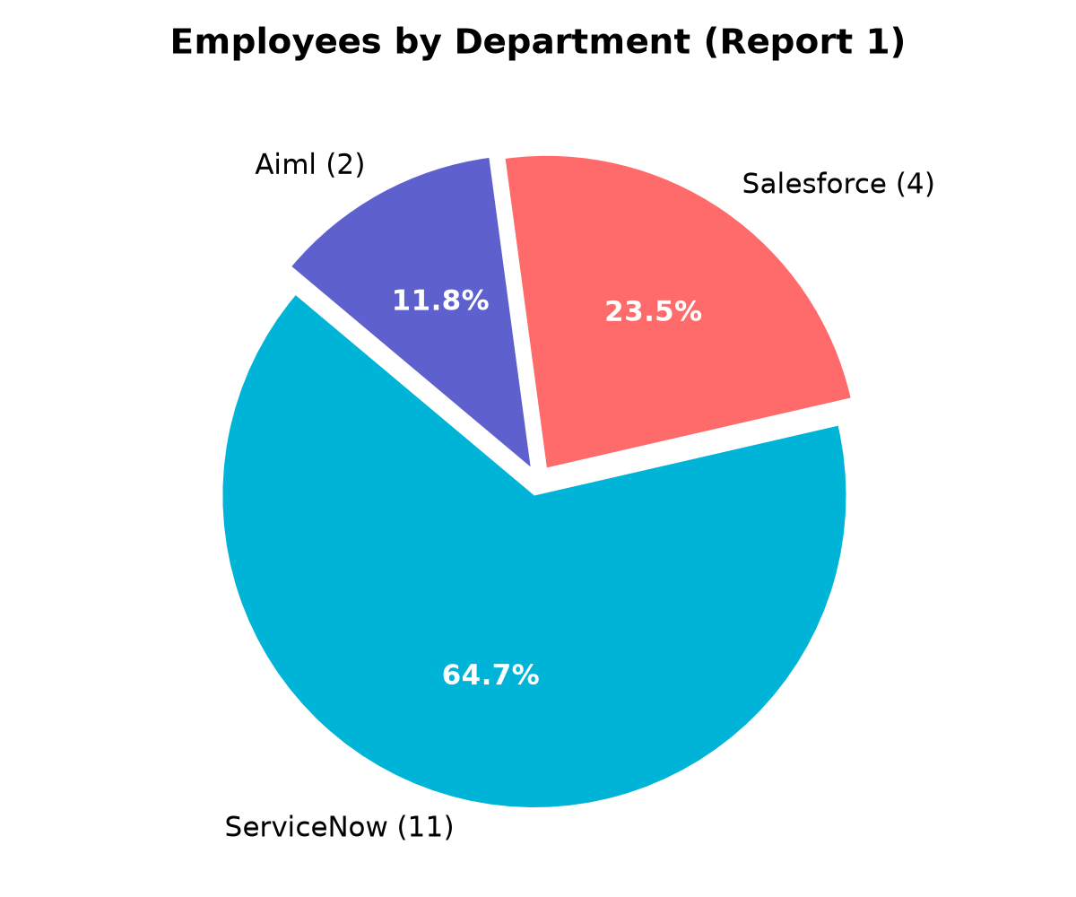
<b>Report 2: Employees by Location (Bar Chart)</b><br/>Hyderabad: 16 | Chennai: 1
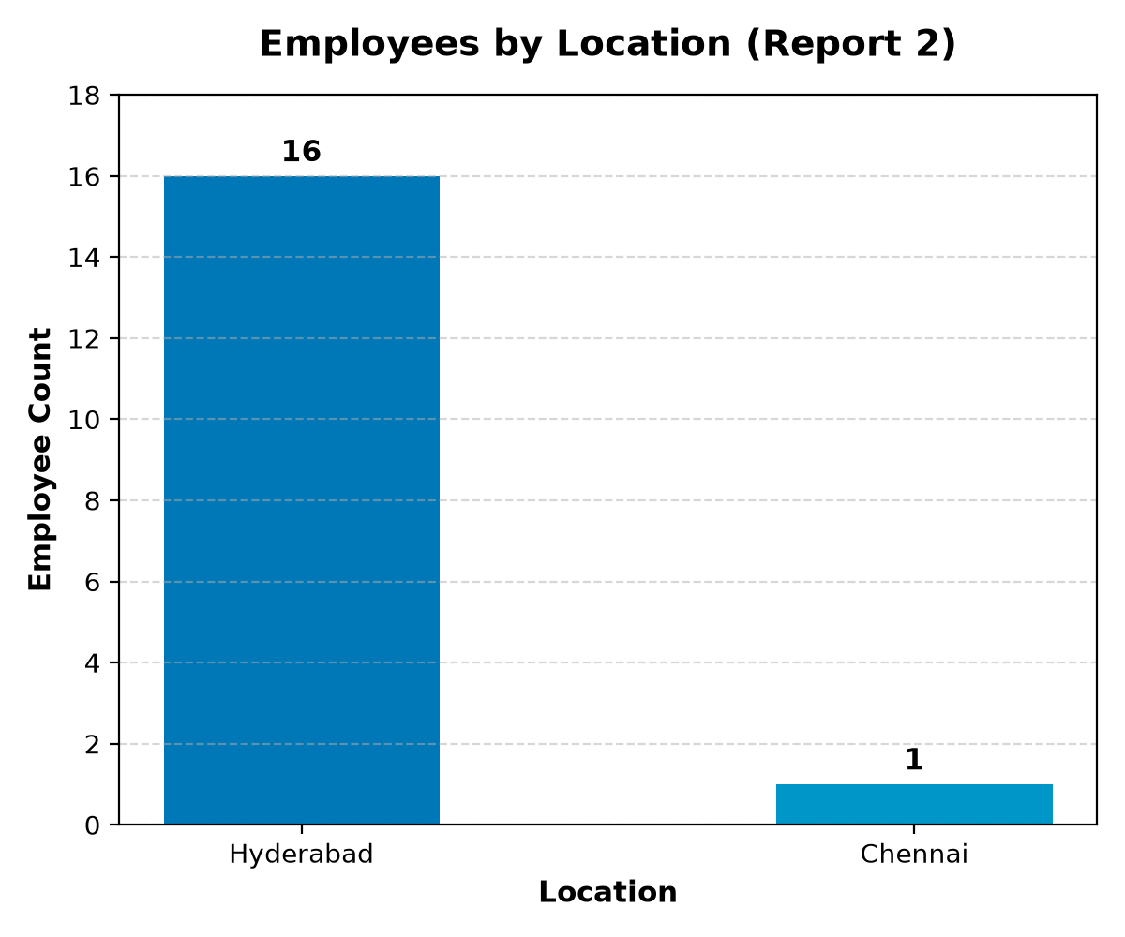
<b>Executive Dashboard Consolidated View</b>
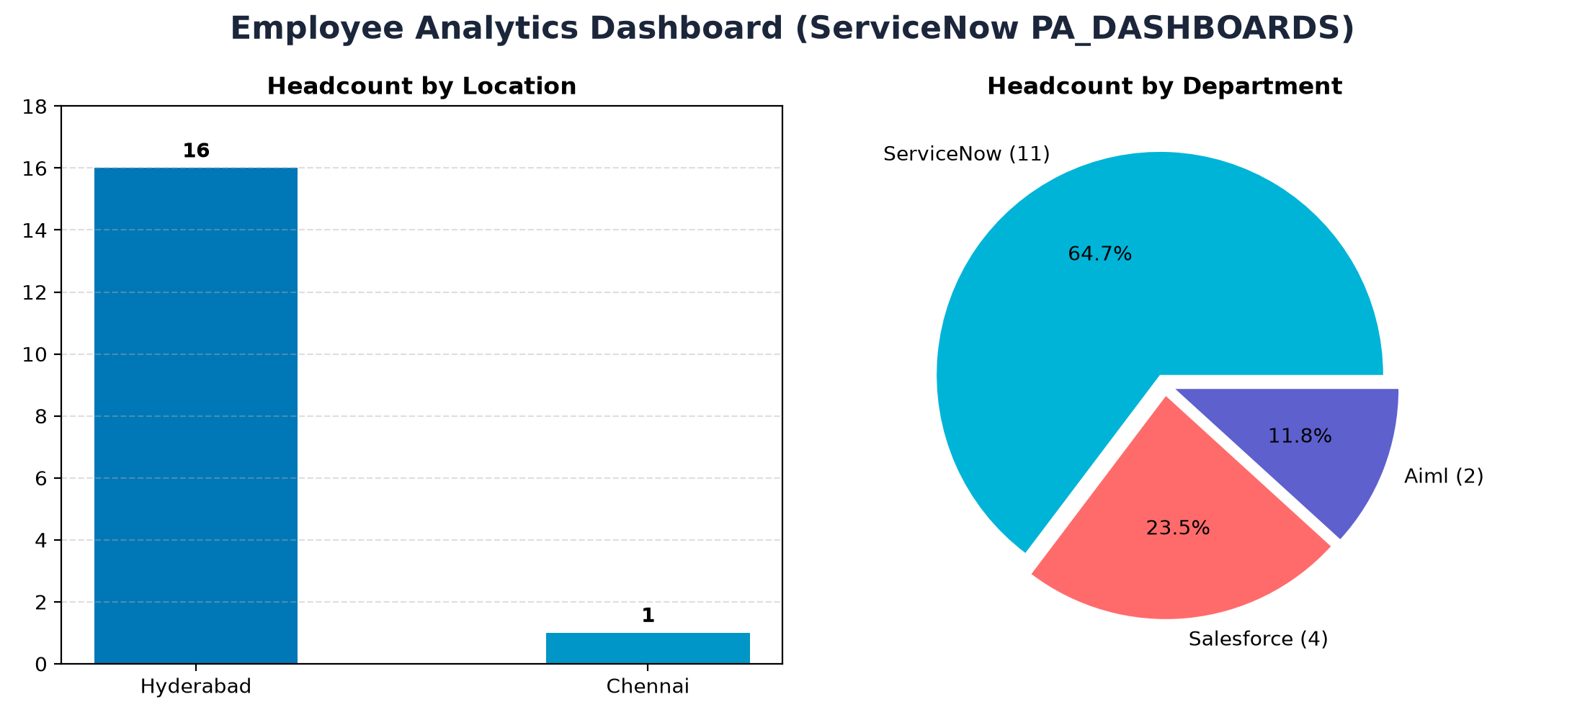
4. Conclusion & Key Takeaways
1. <b>Automated Data Pipeline:</b> The implementation replaces error-prone manual entry with a resilient, automated staging and transformation architecture.<br/>2. <b>Guaranteed Data Integrity:</b> Enabling Coalesce on Employee ID ensures that repeated imports update existing records rather than creating redundant duplicates.<br/>3. <b>Executive Decision Support:</b> Centralized dashboards and dynamic reports offer immediate, real-time insights into workforce metrics across departments and geographic locations.

